RISK ASSESSMENT FOR ALPHA DREAMERS BANK CONSORTIUM LOAN PORTFOLIO ANALYSIS

1. The Business Problem: Balancing Growth and Risk
Alpha Dreamers Bank faces a challenge common to the financial sector: optimizing a large-scale loan portfolio (252,000 active loans) while maintaining a stable default rate. Currently, the bank operates with an overall default rate of 12.3% as per the pie chart below:
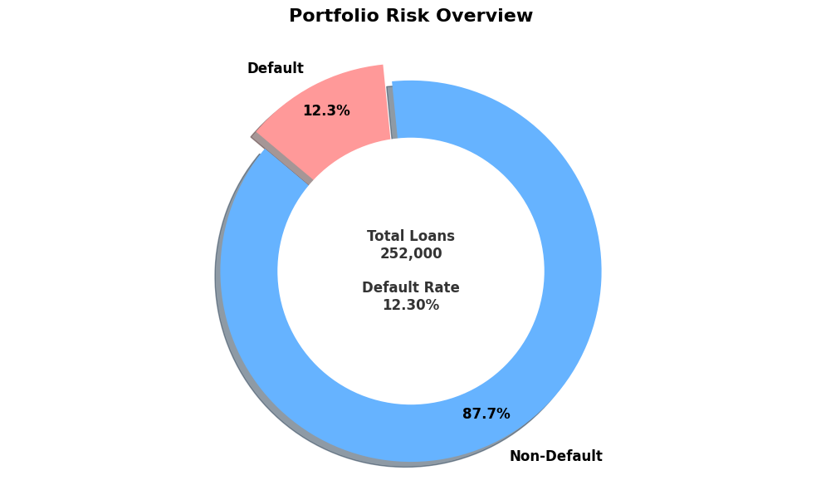
Chart 1
The core business problem lies in identifying the high-risk segments defined by applicant demographics, socioeconomic status, and geographic location to refine credit underwriting models. By understanding the ‘Risk Density’ across various variables, the bank aims to reduce losses from "Charged Off" loans while continuing to serve profitable market segments.
2. Key Insights and Research Questions Answered
The EDA process utilized a series of high fidelity visualizations to answer specific research questions regarding the drivers of loan defaults.

A. Socioeconomic and Professional Risk Factors

Research Question 1
Do specific professions or job stability levels correlate more strongly with loan defaults? The analysis revealed significant variance across different career paths.
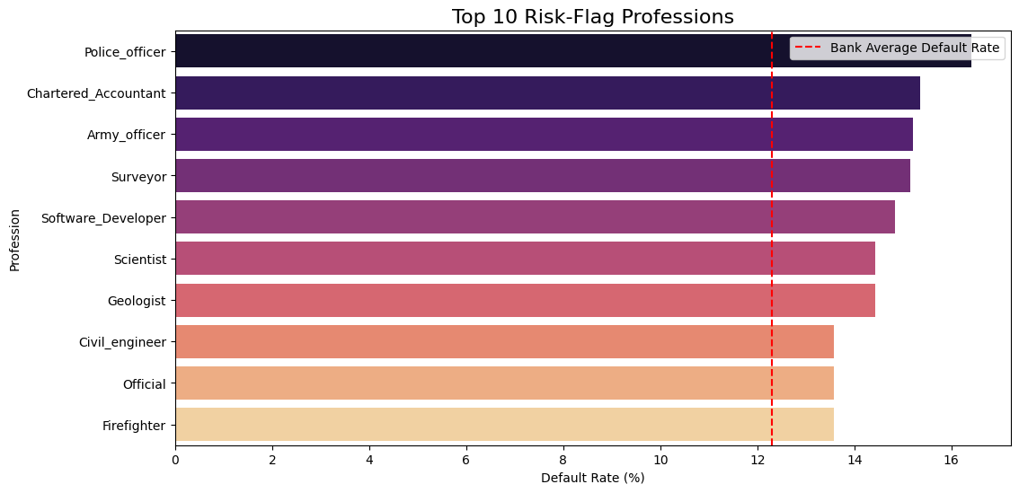
Chart 2
- High-Risk Professions: Police officers (approx. 16.5%), Chartered Accountants, and Army Officers exhibit default rates significantly higher than the bank’s 12.3% average.
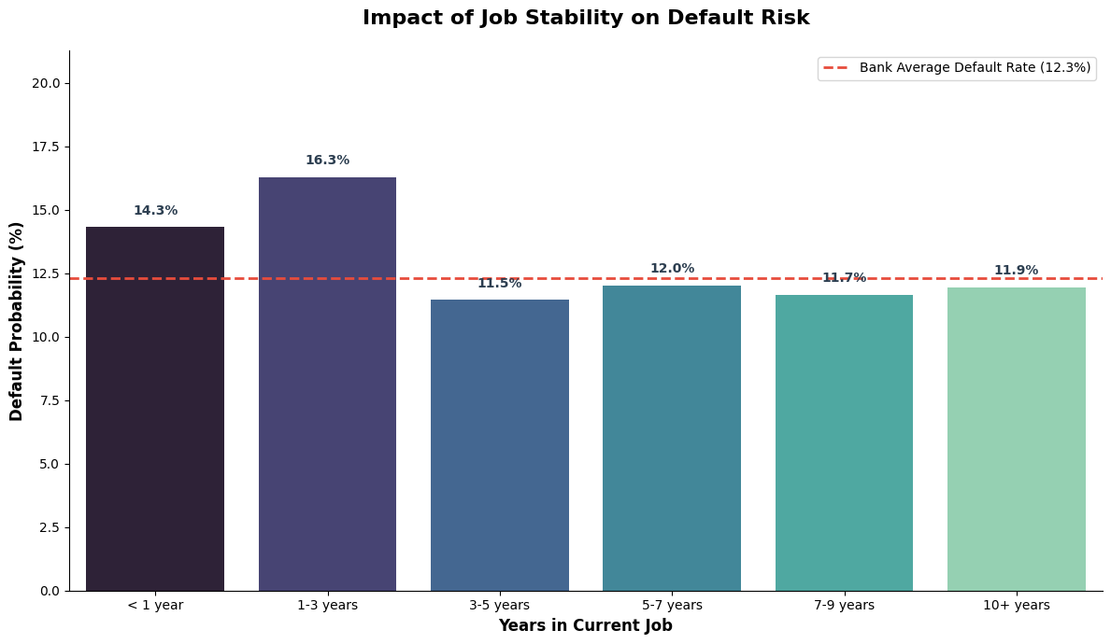
Chart 3
- Job Stability: A critical non-linear trend was observed in job stability. Applicants with 1–3 years of experience have the highest default probability (16.3%), whereas risk tended to stabilize or decrease slightly as tenure exceeded five years.

B. Demographic and Marital Status Impact
Research Question 2
How do age and marital status influence repayment behavior?
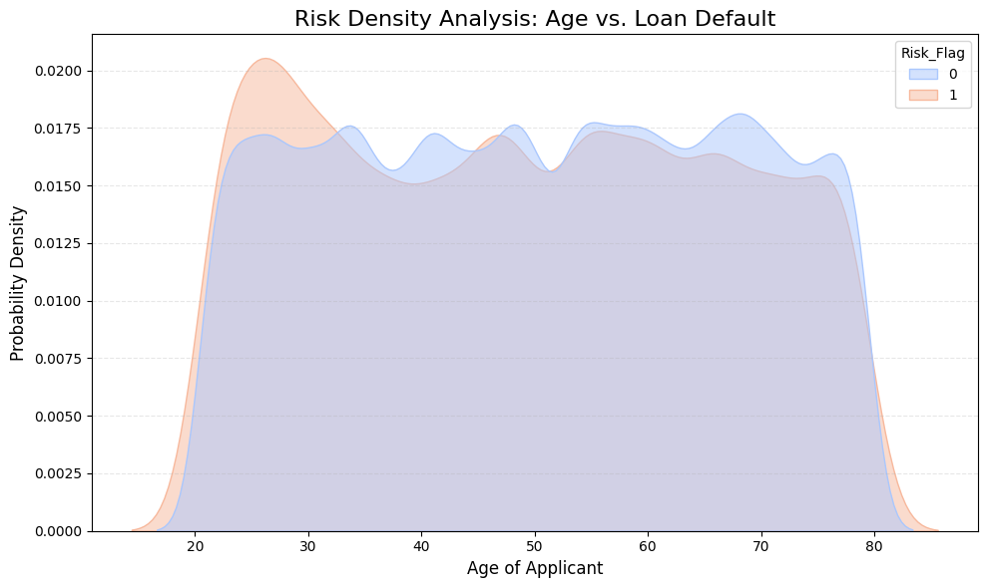
- Age Density: The Risk Density Analysis shows a "risk spike" in younger applicants, particularly those in their mid-20s. While the distribution of non-defaulters is relatively even across ages 30–80, the density of risk is most concentrated in the early career stage.
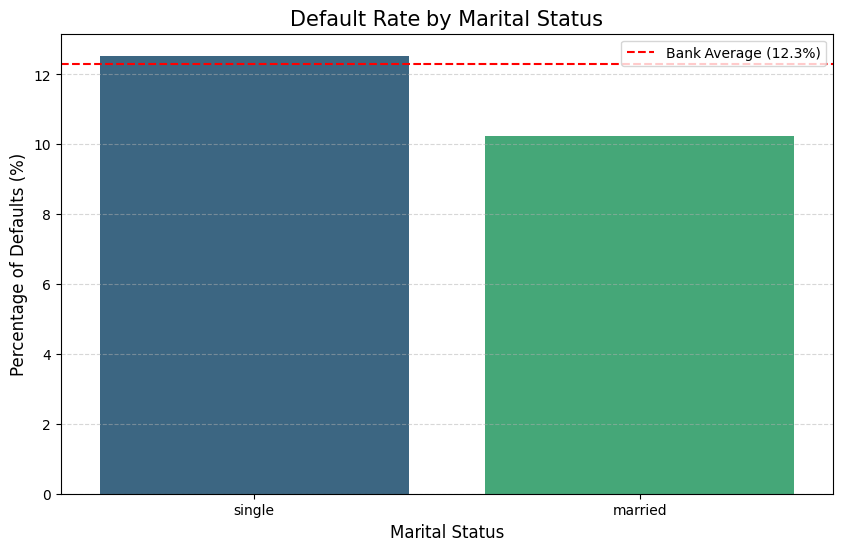
- Marital Status: Marital status proved to be a notable predictor. Single individuals defaulted at a rate higher than the bank average, whereas married applicants demonstrated significantly lower default probabilities (approx. 10.2%).

C. Financial and Income Brackets
Research Questionm 3
Does a higher income level guarantee lower default risk?
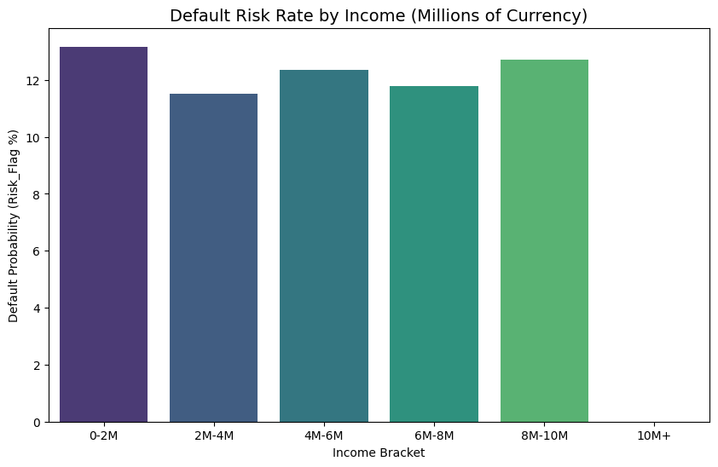
- The Income Paradox: Interestingly, default risk does not follow a perfectly linear downward path as income increases. While the 0–2M income bracket shows high risk, a secondary spike occurs in the 8–10M bracket (approx. 12.8%). This suggests that "over-leveraging" is a risk even among high earners.

3. Geographic and Asset-Based Findings
Research Question 4
Where is the risk geographically concentrated, and how does asset ownership mitigate it?
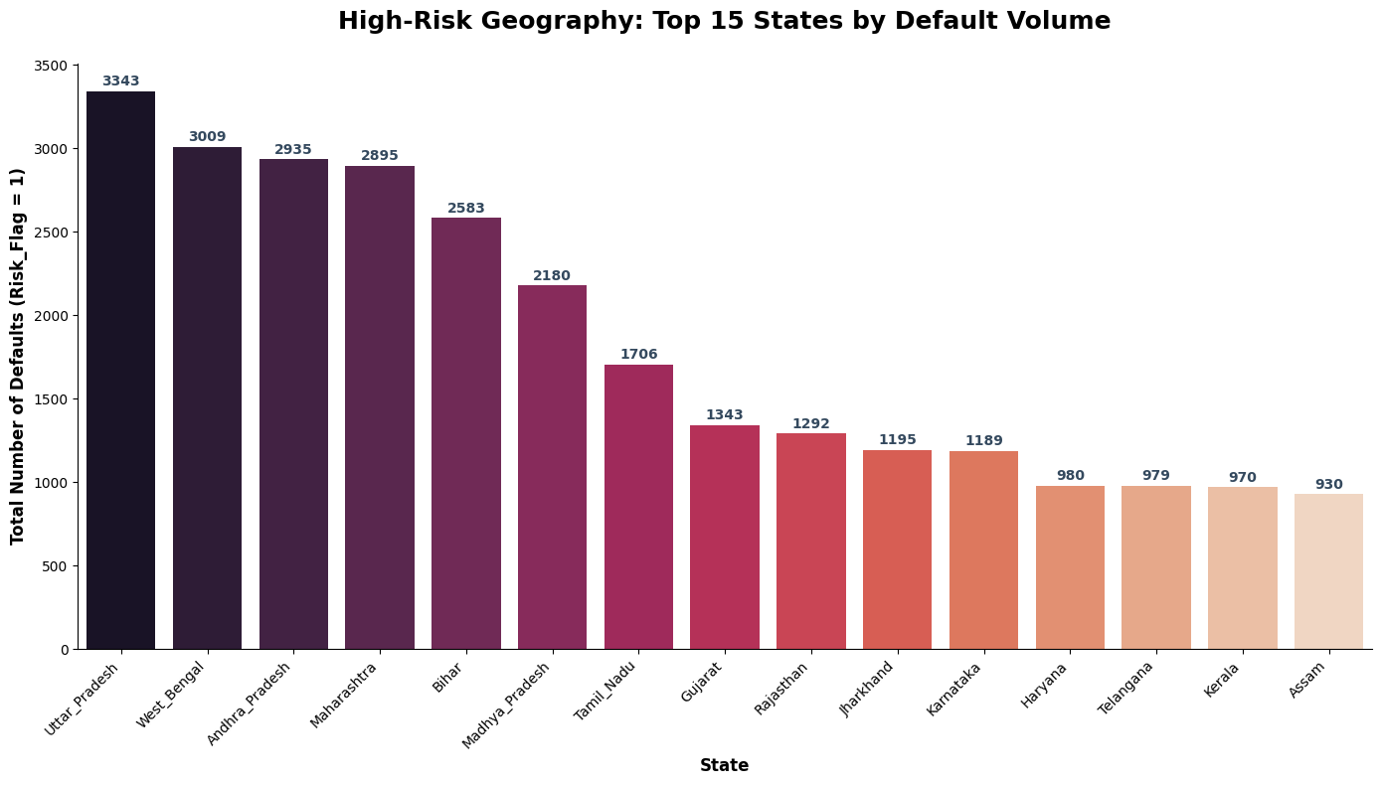
- Geographic Hotspots: Uttar Pradesh (3,343 defaults) and West Bengal (3,009 defaults) are the high-volume risk leaders. At the city level, Kochi and Satna recorded the highest absolute numbers of defaulters.
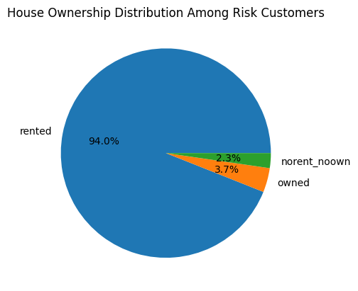
- Housing Stability: A staggering 94% of all risky customers are in rented accommodations. Only 3.7% of defaulters owned their homes, highlighting that home ownership is perhaps the strongest single indicator of loan safety in the bank's current portfolio.

4. Conclusion and Strategic Recommendations
The EDA process has successfully shifted the bank's understanding from a general "12.3% risk" to a granular "Segment-Specific Risk."
Moving forward, Alpha Dreamers Bank should:
- Refine Underwriting for the 1–3 Year Job Bracket: Implement stricter verification or lower loan limits for this specific career phase.
- Target Homeowners: Create incentive-based loan products for homeowners, as they represent the lowest-risk segment.
- Geographic Adjustments: Re-evaluate credit scoring in high volume default states like Uttar Pradesh and West Bengal.
By addressing these specific "risk clusters," the bank can strategically lower its default rate while maintaining its volume of 252,000 loans.

